Excel and Visual Basic (VBA) Tutorial

Show the Developer tab for Microsoft Excel (PC)

- Start MS Excel.
- Click the File tab.
- Click Options.
- In the categories pane, click Customize Ribbon.
- In the list of main tabs, select Developer.
- Click OK to close the Options dialog box.

Alternatively in Excel,
1. (Upper Menu Bar) – Tools
2. Excel Add-ins

Be sure that you have installed the add-in Analysis ToolPak – VBA. Click the MS Office circle in the top left corner then select ‘Excel Options’ at the bottom of the new window. At the bottom of the new window select ‘Go’ and check the boxes for Solver, Analysis ToolPak, and Analysis ToolPak VBA.

Generating Random Numbers
1. Go to cell A1 and type ‘=rand()’
This command generates random numbers between 0.00 and 0.99 up to 15 decimals. Copy this down to cell A10. Hit the f9 key to generate a new set of numbers.

2. Using VBA
- Clear the spreadsheet and select the ‘Developer’ tab
- Select ‘Record Macro’ and name it RandomNumber (no spaces)
- Click on cell A1 type ‘=rand()’ copy this down to cell A10.
- Hit ‘Stop Recording
2. Using VBA(cont.)

Add a Button
- Select ‘Insert’ and choose the first button icon under ‘Form Controls’
- Drag your mouse to form the rectangular shape of the button
- Assign the Macro to the RandomNumber macro by clicking on RandomNumber in the box.
- Click inside the button and rename it – ‘Random Numbers’
- Delete cells A1:A10
- Click the button to generate new random numbers

Optional: Creating “Spin Buttons (Counters)” in Excel
1. Create a new tab and name the tab “Spin Buttons”
2. Type “Spin Buttons” in cell A1 (use bold & larger font), type “Stock Price” in A5
3. Click and drag row 5 to make it bigger.
4. In cell C5 type “$28”
5. Select the Developer tab and then Spin Button. Move the cursor to cell B5 and use the crosshairs to click/drag and form the shape of the button.
6. Rt click the button and select Format Control. Under Cell Link enter C5.
7. Click the up and down arrows to change the values.

Using “If Statements” in Excel
An If Statement works as follows:
=If (if this is true, then do this, otherwise do this)
Note: Text (words) that you wish to output have to be inside “double quotes” in the formula

Using “VLOOKUP” in Excel
VLOOKUP works as follows:
=VLOOKUP(look for this cells value or text, over the Excel items in this range, and return the value for this column(s) within the range into this cell(s))
Note: VLOOKUP is designed to pull one value per reference but you may extract more than one item from the range by using these brackets { }
Using Solver

Create the Sharpe Ratio in cell N14: (R_{p} - R_{f})/σ
Run Solver to Maximize cell N14 by changing the Weights.

Creating a User Defined Function in Excel
1. Select the Create Function tab at the bottom of the spreadsheet
2. Hit [Alt] [F11]
3. Select Insert then Module
4. Type function area (length, width) and hit enter
5. In the newly created space type: area = length * width
6. Go to the cell for calculating 'area', select Formulas from the toolbar and then Insert Function fx
7. From the drop down box choose the category User Defined and Area should appear as one of the choices
8. Enter the cell references for Length and Width
Length Width
7 9

Optional: Create Future Values with Continuous Compounding to include Volatility
Lump Sum – Create a User Defined Function
1. Create a Function called FV_Volatility
2. Hit [Alt] [F11]
3. Select Insert then Module
4. Type: Function FV_Volatility (PV, Rate, Var, Time)
5. Then type: FV_Volatility = PV * Exp((rate-.5*Var)*time)
6. Go to cell C10 and select Formulas, Insert Function fx
7. Search under User Defined Functions
8. Enter the required information

Payment – Using a Macro and Button
1. Select Developer then choose Record Macro
2. Call the Macro FV_Volatility_PMT
3. Go to cell C13 and enter the following formula:
=C4*((EXP((C5-C6^2/2)*C7))-1)/(EXP((C5-C6^2/2))-1)

4. Hit Enter and Stop Recording Macro
5. Select Developer – Insert (dropdown) – Form Controls
6. Choose the top left button icon and go to cell I12 and drag the shape of the button
7. Assign the button to the FV_Volatility_PMT macro
8. Click on the text inside the button – delete the existing label and type FV_Volatility_PMT
9. Go to cell C13 and delete the value...click on the new button to calculate

Optional: Create and graph a normal distribution in Excel
Go to the Normal Distribution tab
Use =normsinv(Rand()) to create Z-scores
Convert the Z-scores to returns where, return = mean + Z-score * standard deviation
Graph
Go to Data - Data Analysis - Histogram
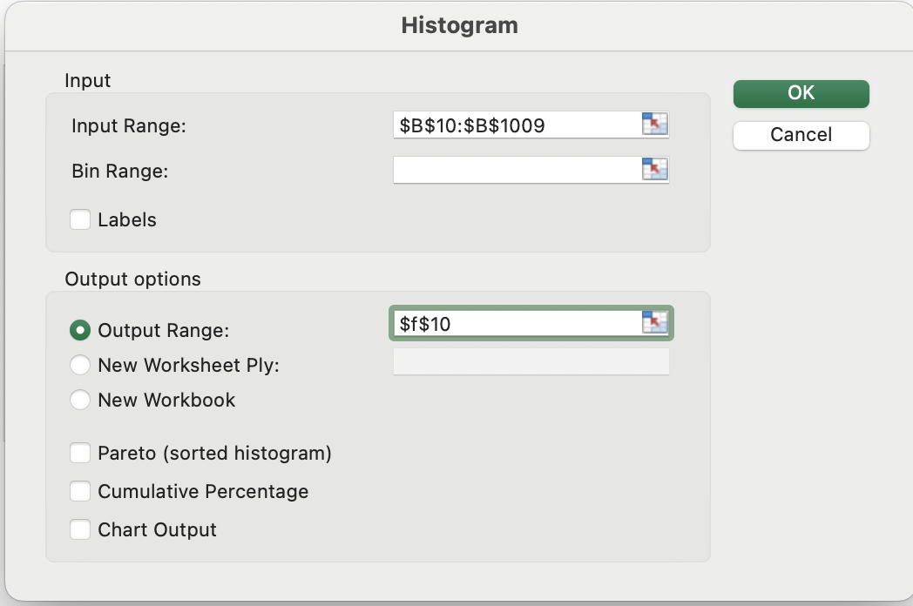

With the output selected got to Insert – Graph (or Recommended Chart)

Creating Macros using VBA Code – Getting Started
Select the VBA Practice tab at the bottom of the spreadsheet.
For VBA there are two commands you must know - [Alt] [F11] and [Alt] [F8]
(For a mac use fn+option+F11 and fn+option+F8)
[Alt] [F11] – opens the VBA window where you will write your macros.
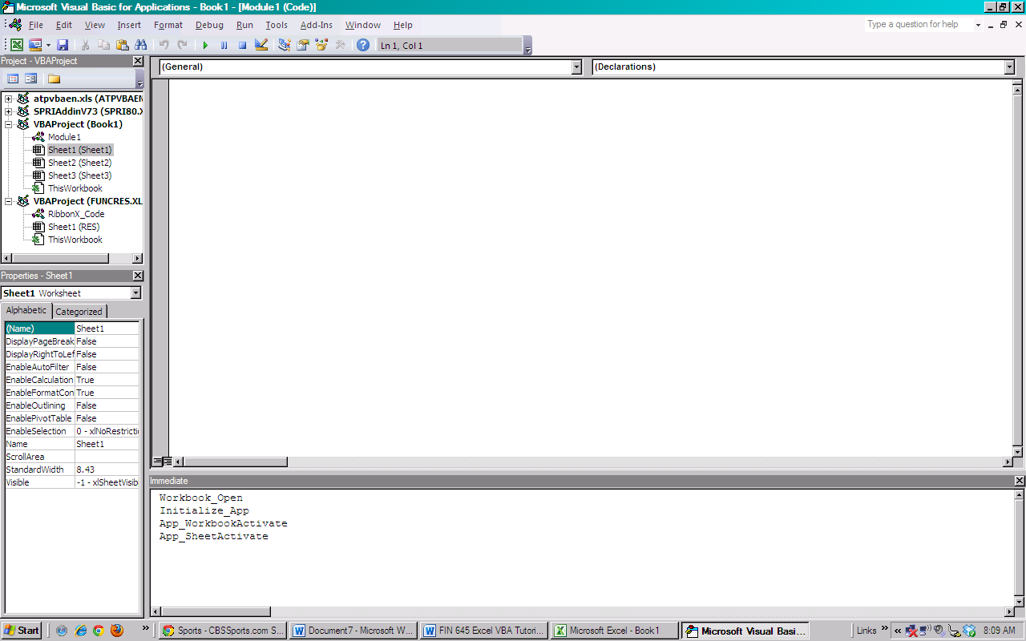

[Alt] [F8] – Brings up all of your existing macros
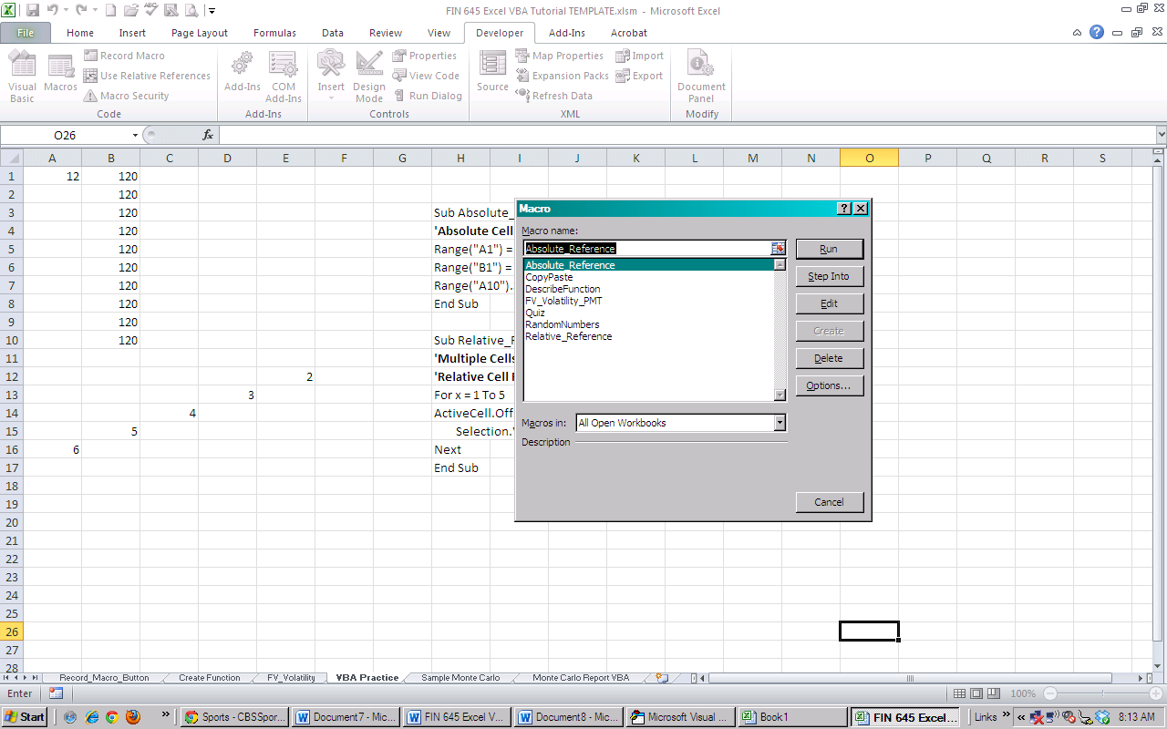
Getting Started
Let’s start by having the macro put “Hello World” in cell D1, for example. Hit [Alt] [F11] to open the VBA Editor and then select Insert and Module. Each macro must start with the command:
Sub The_Name_of_your_program (spaces are not allowed) and parentheses ()
Type sub HelloWorld () and hit enter
Notice the program will automatically capitalize the command “Sub” and put End Sub after. Your macro will be placed inside of these two commands:
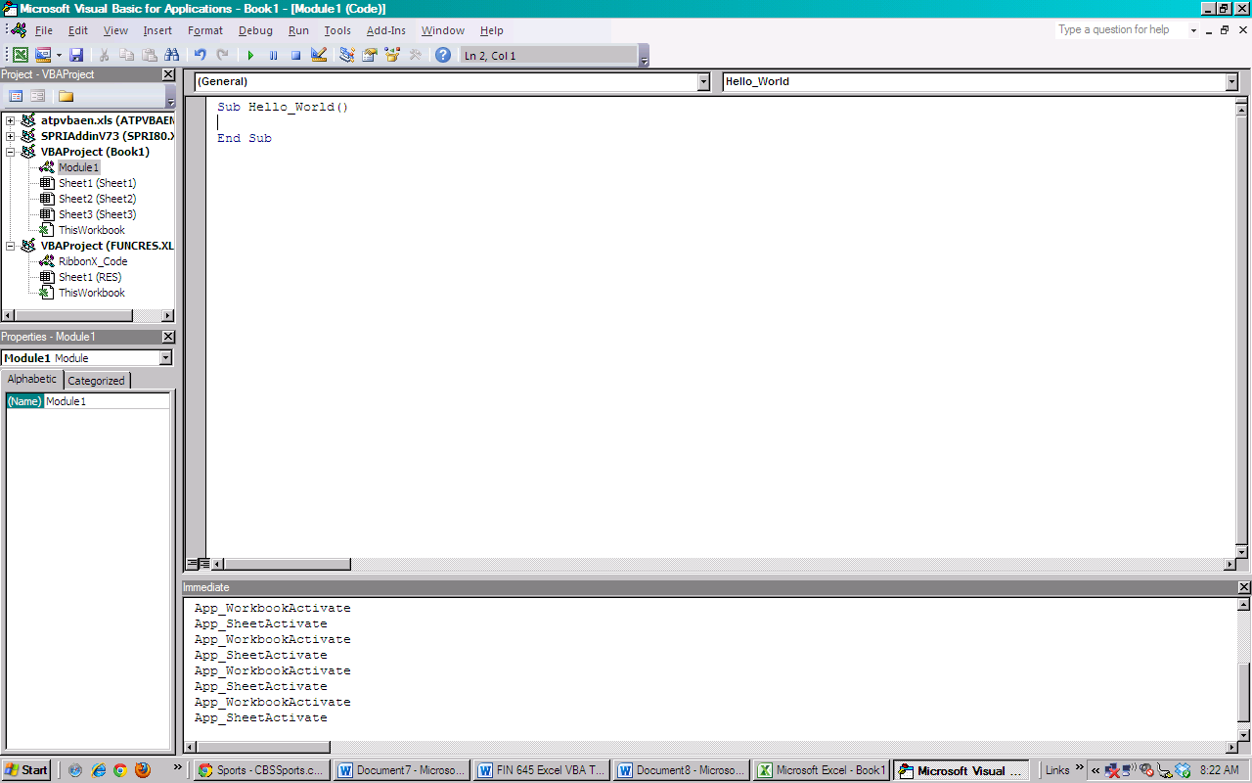
If you make an error (such as leaving a space between Hello and World) the VBA Editor will let you know there is an error by changing the font color to red.
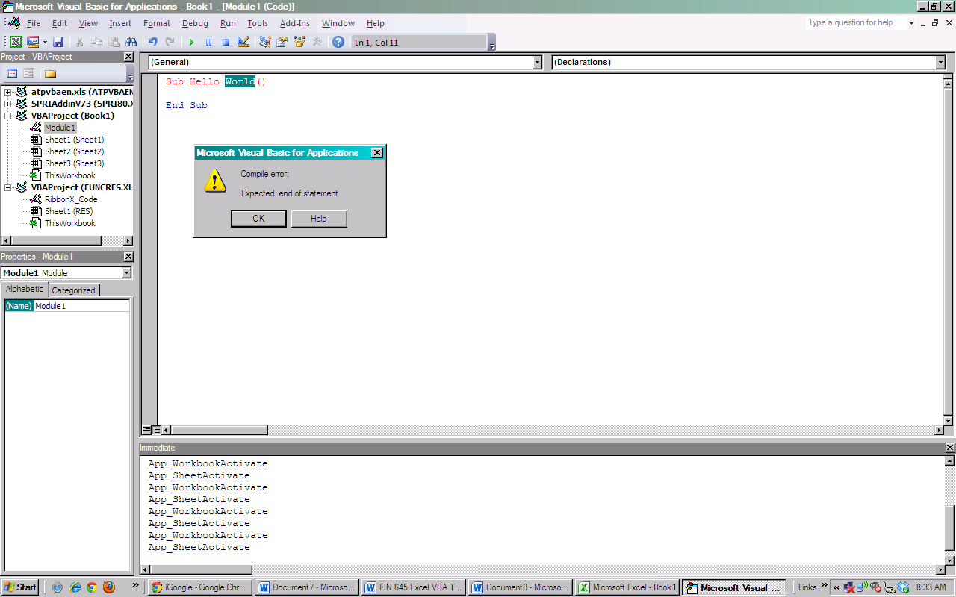
In VBA you may refer in a certain cell directly (Absolute Cell Reference) or you may allow the macro to run from whatever cell you happen to place the cursor (Relative Cell Reference).
To put “Hello World” in cell D1, move the cursor to D1 and type the command:
ActiveCell = “Hello World!”
ActiveCell tells the macro to execute the commands in whatever cell the cursor is placed.
To run the macro select the Run tab or hit the green arrow.

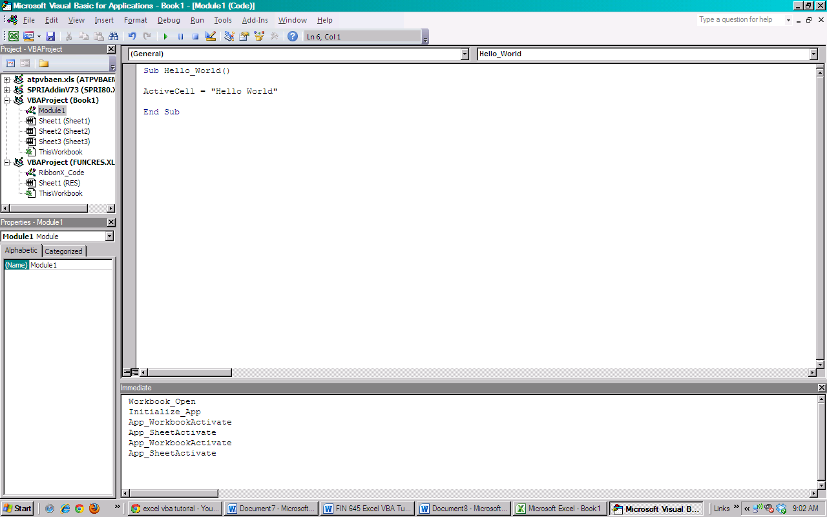

Go back to the spreadsheet....

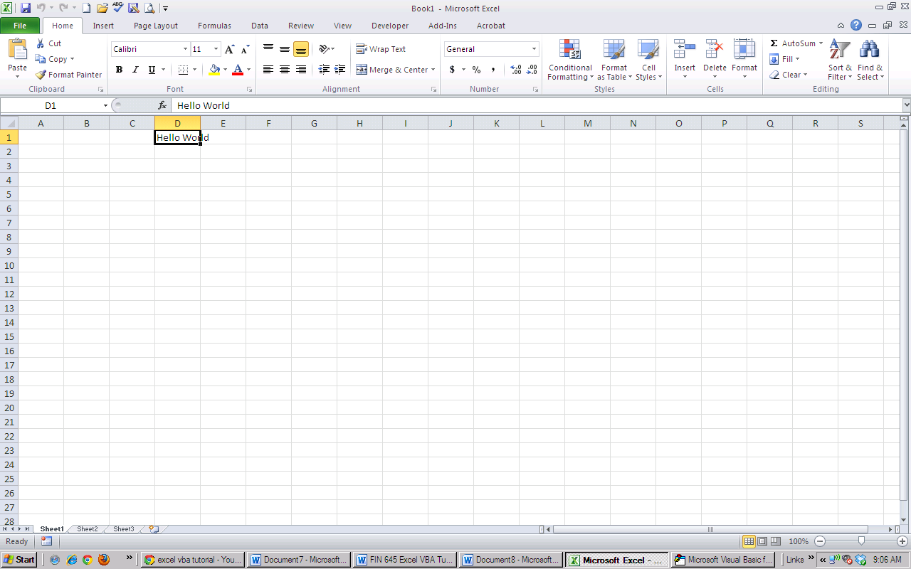

How to refer to cells using VBA
Go to the Cell References tab…
https://www.youtube.com/watch?v=c8reU-H1PKQ
Replicate the video – STOP at 10:17 into the video skip to 20:00 Stop at 23:00
Range, ActiveCell, Cells

How to Write a “For Next” Loop
Watch this short video:
https://www.youtube.com/watch?v=NTfa1kpLX-0&t=330s
Replicate the video – STOP at 7:10 into the video.

Practice Loop
Go to the Practice Loop tab in the Excel VBA Tutorial Template. Create a VBA subroutine that utilizes a For /Next Loop which takes the value in cell A1 and puts it into cells D6 through D15.

Assignment
Monte Carlo with VBA
Write the code to run the Monte Carlo simulation 1000 times.
Hints:
- Name the sub routine Sub MonteCarlo ()
- Start the Loop for 1000 trials with the For x = (1 to 1000…or 18 to 1018…)
- The first number (1 or 18) determines the row where the 1000 trials will be output
- Put the 1000 simulation results in Column K (Column A=1, B=2, C=3…)
- Use Cells (x,?).Value = The column where the FV for the simulated lifetime is located.Value and what you want to go in that cell follows the =
- Just before the End Sub command add a command to move the cursor to cell A1.
* By selecting cell A1 at the end your macro will scroll back up to the top
Advanced Practice (Not Required) – see below
VBA for Efficient Frontier
Open the MVO tab and write the macro to complete the efficient frontier. Start by setting the Portfolio Variance equal to 5 percent.

The VBA code to run Solver is:
DoEvents
Range("$B$5:$K$5") = 0.1
DoEvents
SolverSolve UserFinish:=True
SolverFinish KeepFinal:=1

Note: DoEvents passes control to the operating system. Control is returned after the operating system has finished processing the events

